**TỔNG QUAN**

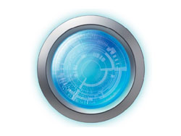

All in One Imaging Solution: Observation, Image Capture, Measurement, and Sharing

The DSX510 digital microscope is an easy-to-use, all-in-one imaging system designed to provide detailed analysis and reports. An intuitive touch screen-based user interface and up to 9,000x magnification enable users of various experience levels to obtain reliable measurement and inspection results.

[Observation](https://www.olympus-ims.com/en/microscope/dsx510/#missing-fragment:undefined)

* Clear, high-resolution image
* Choose from multiple observation methods with a single click
* Easy to operate

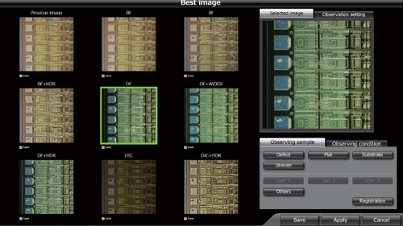

[Image Capture](https://www.olympus-ims.com/en/microscope/dsx510/#cmsContent11144)

* 3D images highlight your samples' true shape
* Obtain all-in-focus images, even for samples with projections
* Automatically acquire panoramic images

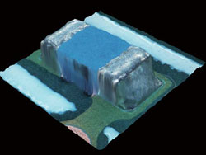

[Measurement](https://www.olympus-ims.com/en/microscope/dsx510/#cmsContent11145)

* Guaranteed measurement accuracy*
* Versatile measurement and analysis tools
* Measure the roughness of surfaces

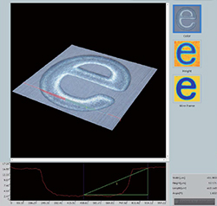

[Sharing](https://www.olympus-ims.com/en/microscope/dsx510/#cmsContent11146)

* Create reports with one click
* Variety of report formats

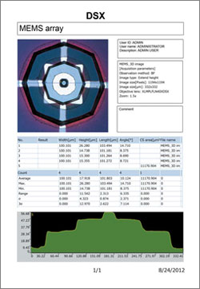

*The accuracy guarantee is based on conditions set by Olympus